

**Online orders tracking**

**⏵⏵⏵Your personal tool**

* **Simple and quick**
* **24/24 h and 7/7 days access**
* **All your orders online**

ID :

PASSWORD :

***Write down your personal access codes and keep it preciously.***

**⏵⏵⏵Access:** http://www.extra.crouzet.com/

**☑ 1 Go to the website and put your ID and password**

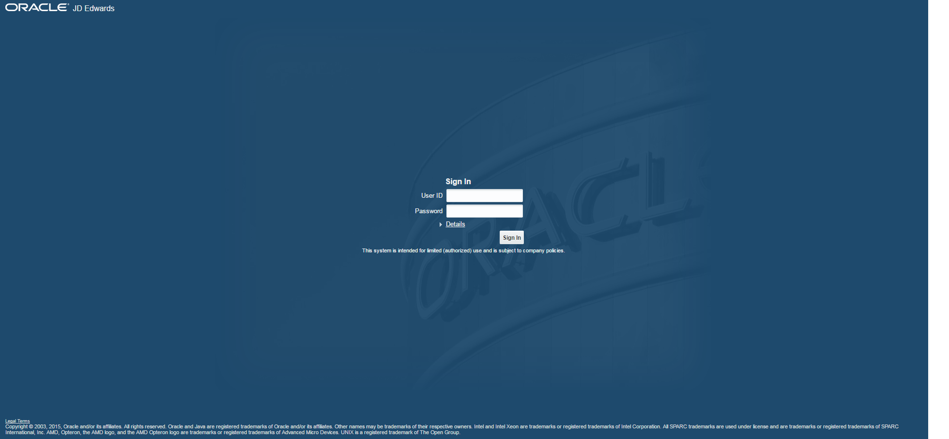

**☑ 2 Access to you personal space**

**Click on “order tracking”**

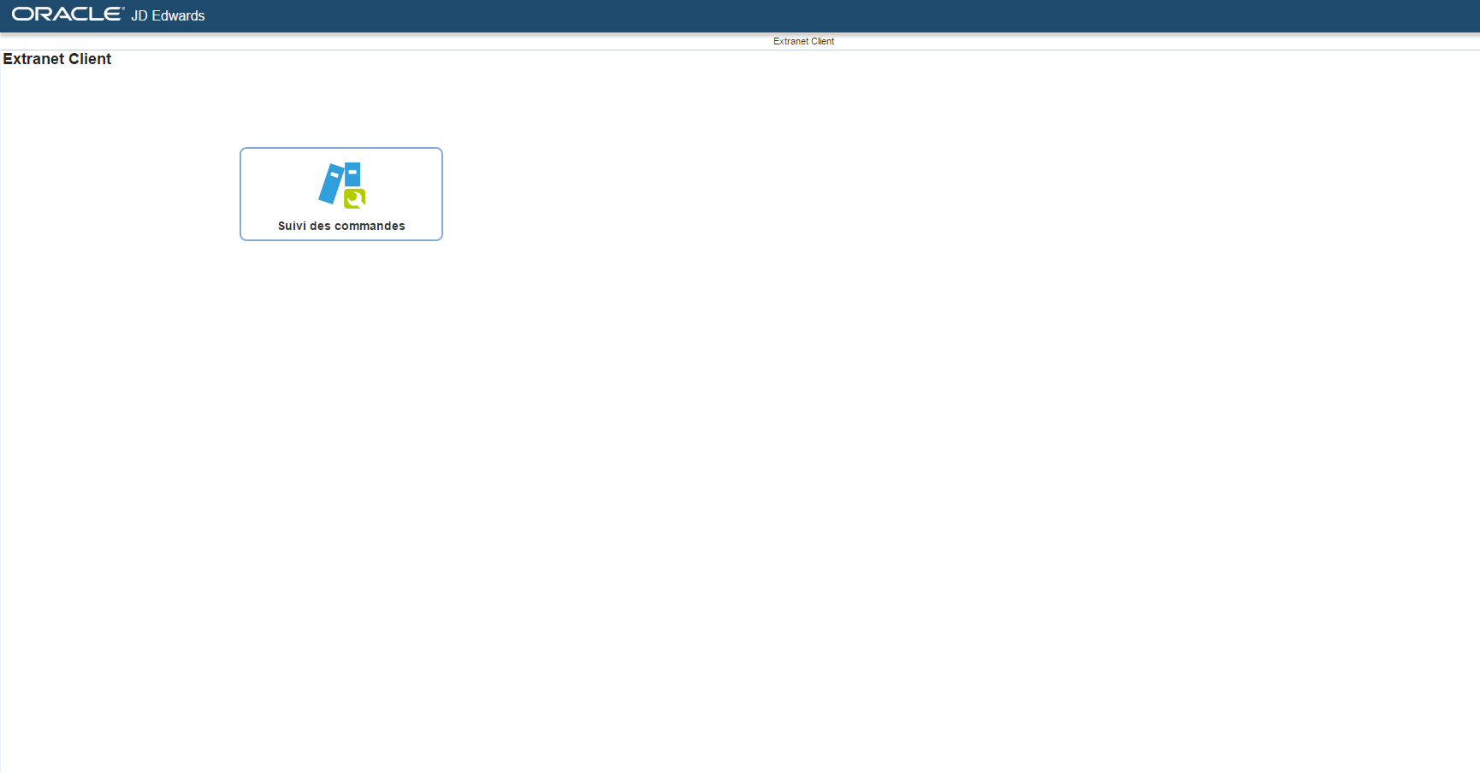

**⏵⏵⏵ Use:**

**☑ 1 View your orders portofolio**

Votre société

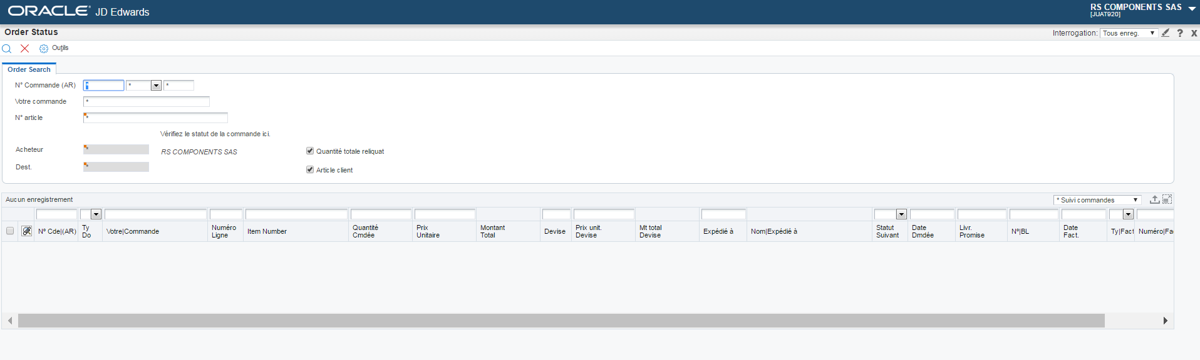

Votre société

**Click on the icon :** 

Votre société

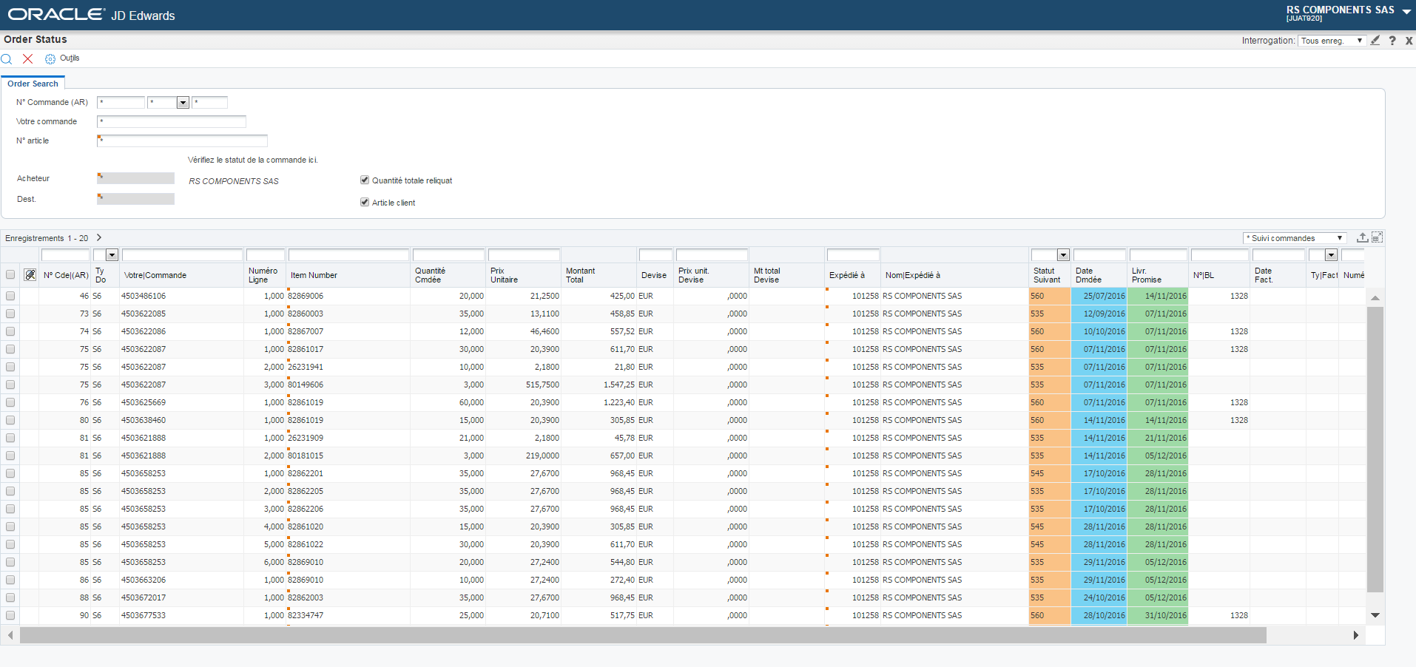

Nom

Expédié à

Votre société

**☑ 2 Track the status of your orders**



Votre société

Nom

Expédié à

Votre société

**☑ 3 Export data :**



Votre société

Nom

Expédié à

Votre société

Click on the icon : 

**⏵⏵⏵ Orders status**

**Definition**

**Status definition:**

524 to 535 =Registered order lines

545 to 560 =In progress order lines

575 to 580 =Shipped order lines

620 =Invoiced order lines

999 =Settled order lines

999 + “Cancel date” indicated =Cancelled order line

**⏵⏵⏵ GLOSSARY**

05/05/2055: Order date not yet confirmed by crouzet ( to be defined)

Typ. Doc : Document type

SO – Standard Order

S6 – Edi order

S7 – Prototype order

S8 – Sample order

SD – Direct order

You have the possibility of filtering by column according to the element that you wish to see appearing

